Web-Based Seminar Booking Management System
A web application for administrators to manage seminar events and system users.

System Overview

The Web-Based Seminar Booking Management System is a smart and easy-to-use tool for administrators to manage seminars and system users online. Instead of juggling papers or spreadsheets, admins can now create, edit, delete, and restore seminar events with just a few clicks.

The system also keeps a record of all admin actions, so every change is tracked and nothing is lost. Super Admins have full control—they can manage other admins, assign roles, and ensure everything runs smoothly. Accessible from any modern browser, this system makes seminar management faster, simpler, and more organized than ever.

Web Page Interfaces
- Login Page
  - The Login Page is the entry point for all administrators to access the system. It is designed to be simple, secure, and user-friendly. Since the system is admin-only, there is no public registration, all admin accounts must be created by a Super Admin.
  - Key Features:
    - Secure Authentication:
      - Uses ASP.NET Core Identity for handling login credentials securely.
      - Only registered admin users can access the system.
    - Error Handling:
      - If an admin enters incorrect credentials, an error message is displayed as a toast notification.
      - Helps users identify login mistakes quickly.
    - Input Fields:
      - Email Field: Admins enter their registered email. Placeholder example: admin@seminar.com.
      - Password Field: Admins enter their password. Placeholder: Enter your password.
      - Both fields are required to ensure proper login.
    - Sign In Button:
      - Submits the login form and validates credentials.
      - Redirects to the Dashboard upon successful login.
    - Footer Text:
      - Provides a note for users who do not have access: “Contact your Super Admin if you need access.”

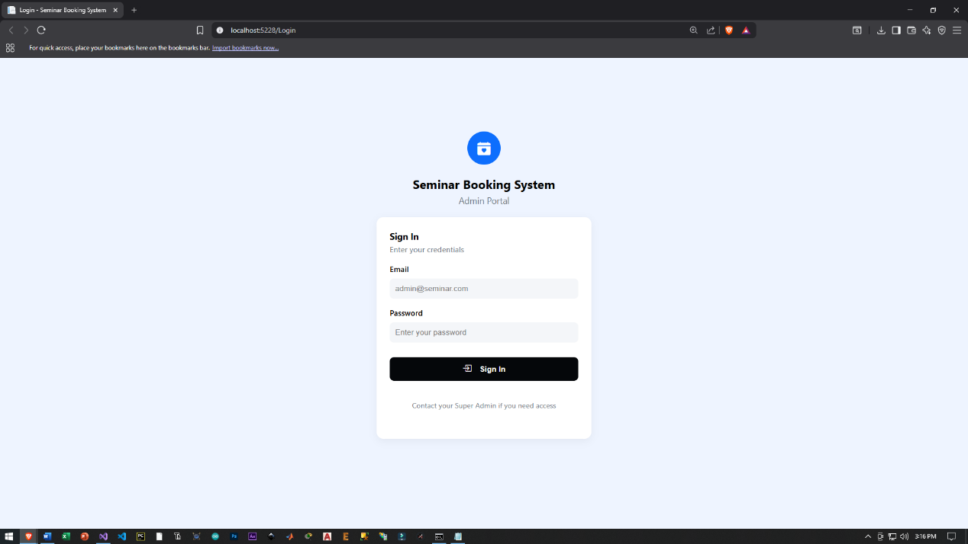

- Dashboard
  - The Dashboard is the main page displayed after a successful login. It provides administrators with a quick overview of the system, including seminar statistics, recent activities, and upcoming events. It is designed to help admins monitor and manage seminars efficiently in one place.
  - Key Features:
    - Summary Cards
      - Displays important system information at a glance.
      - Total Seminars Card: Shows the total number of seminars and how many are upcoming.
      - Activities Card: Shows the total number of admin actions recorded in the system.
    - Upcoming Seminars Section
      - Displays a list of all upcoming seminars.
      - Each seminar shows:
        - Title
        - Location
        - Date
        - Status (e.g., upcoming, ongoing)
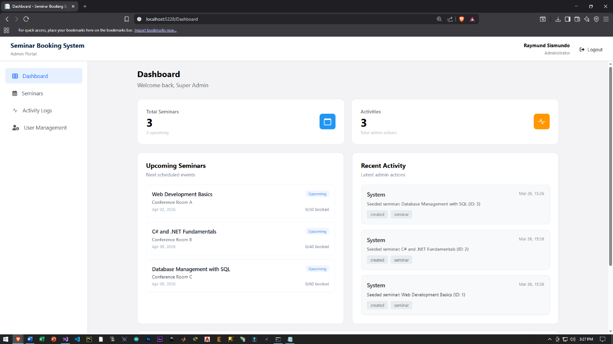
        - If there are no upcoming seminars, a message “No upcoming seminars” is displayed.

    - Recent Activity Section
      - Shows the latest actions performed by administrators.
      - Each activity includes:
        - Admin/User ID
        - Date and time of action
        - Description of the action
        - Action type (e.g., create, update, delete)
        - Entity affected (e.g., seminar)
      - If no activity is recorded, it displays “No recent activity.”

    - Quick Actions
      - Provides shortcut buttons for commonly used tasks:
      - Create Seminar: Redirects to the seminar creation page.
      - View Logs: Redirects to the activity logs page.
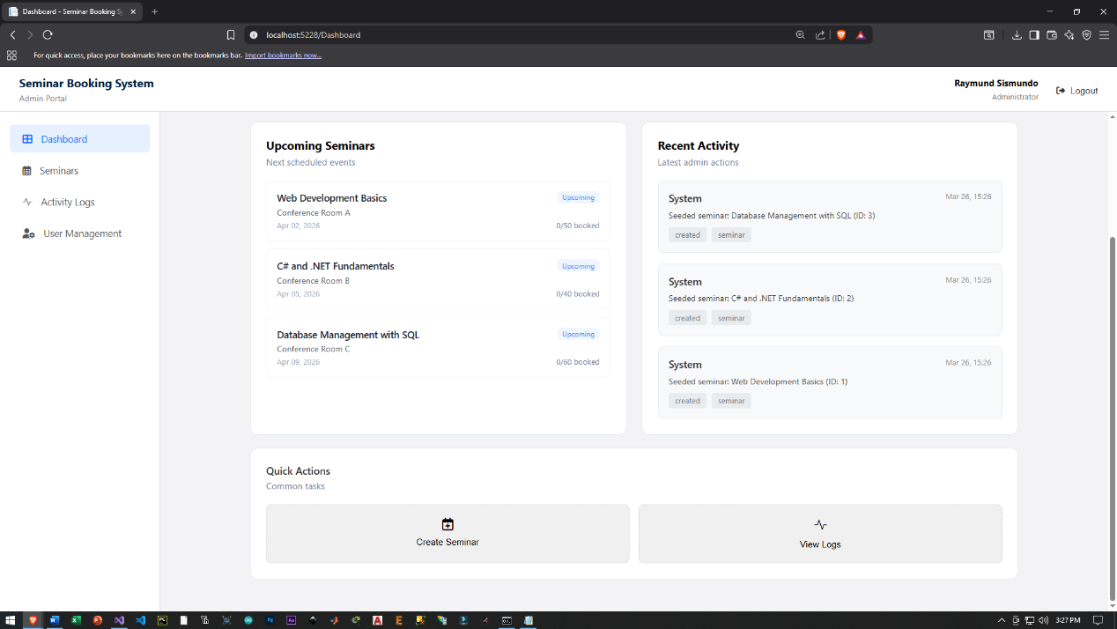
      - Helps admins perform actions faster without navigating through menus.

    - User Greeting
      - Displays a welcome message (e.g., “Welcome back, Super Admin”).
      - Personalizes the dashboard experience for the logged-in user.

- Seminar Management Page
  - The Seminar Management Page allows administrators to manage all seminar events in the system. It provides tools to create, edit, delete (soft delete), and restore seminars. This page helps admins organize seminar schedules efficiently and keep all seminar information updated in one place.
  - Key Features:
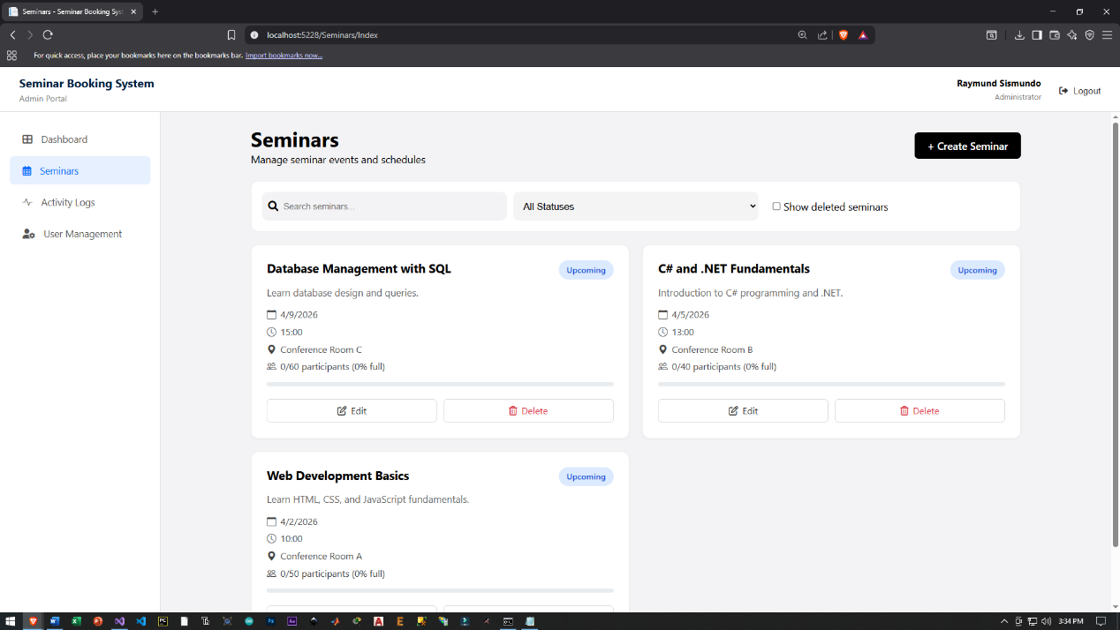
    - View Seminars List
      - Displays all seminars in a structured list or grid format.
      - Each seminar shows key details such as:
        - Title
        - Location
        - Date
        - Status (e.g., upcoming, ongoing)
        - Allows admins to quickly view and monitor all seminars.
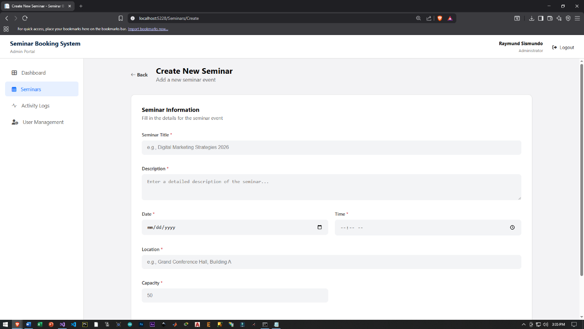
    - Create Seminar
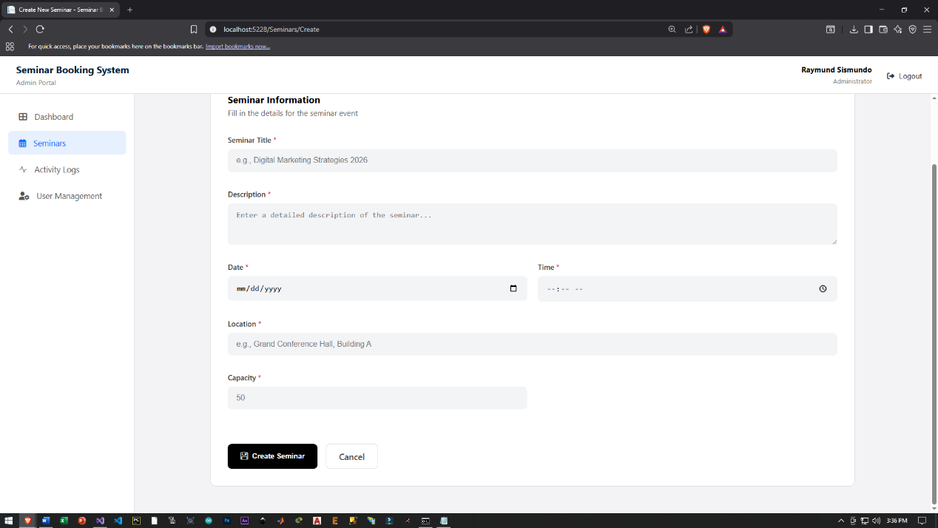
      - Admins can add new seminar events.
      - Requires input such as:
        - Seminar Title
        - Date
        - Location
      - Newly created seminars are saved in the database and displayed in the list.

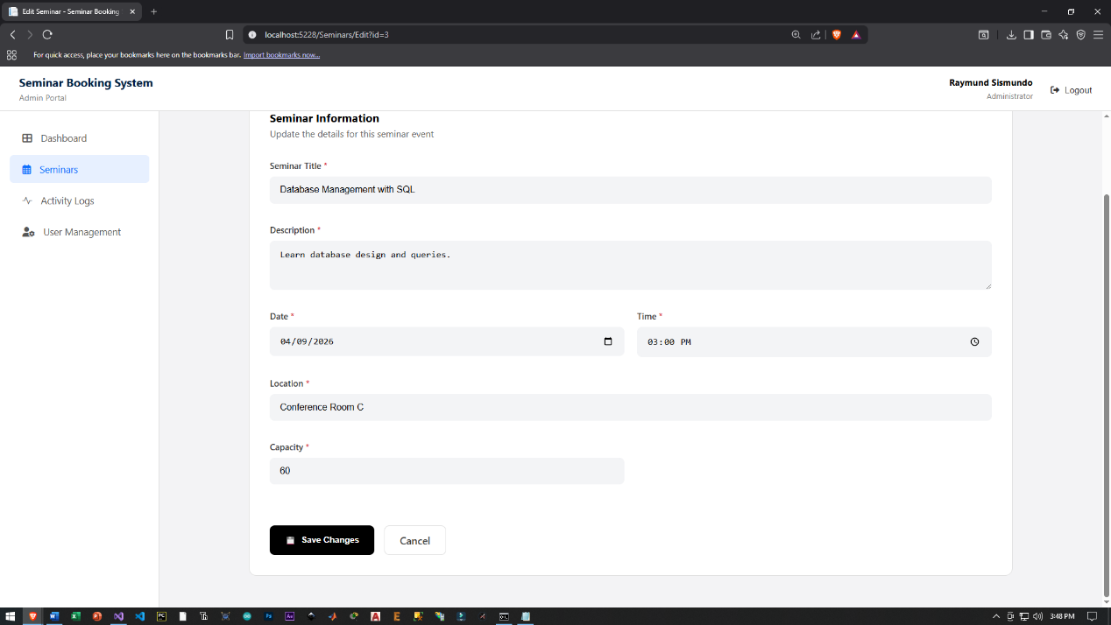
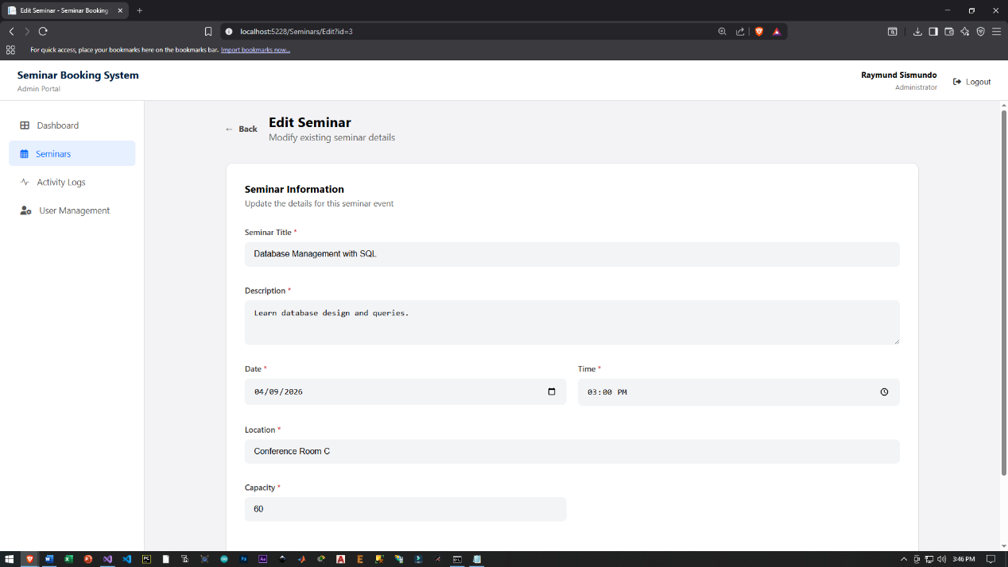
    - Edit Seminar
      - Allows admins to update existing seminar details.
      - Ensures that seminar information remains accurate and up to date.
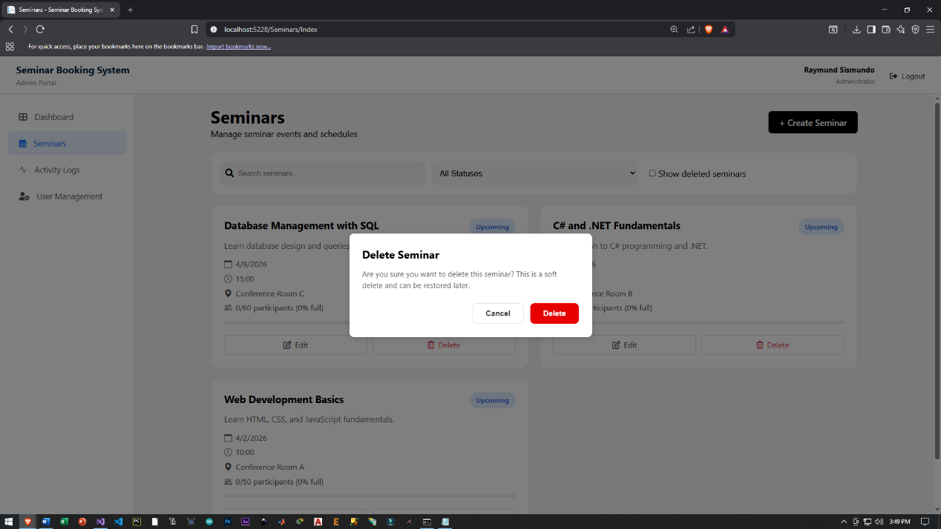
    - Delete Seminar (Soft Delete)
      - Admins can delete seminars when they are no longer needed.
      - Uses soft delete, meaning the seminar is not permanently removed but marked as deleted.
      - Prevents accidental loss of important data.
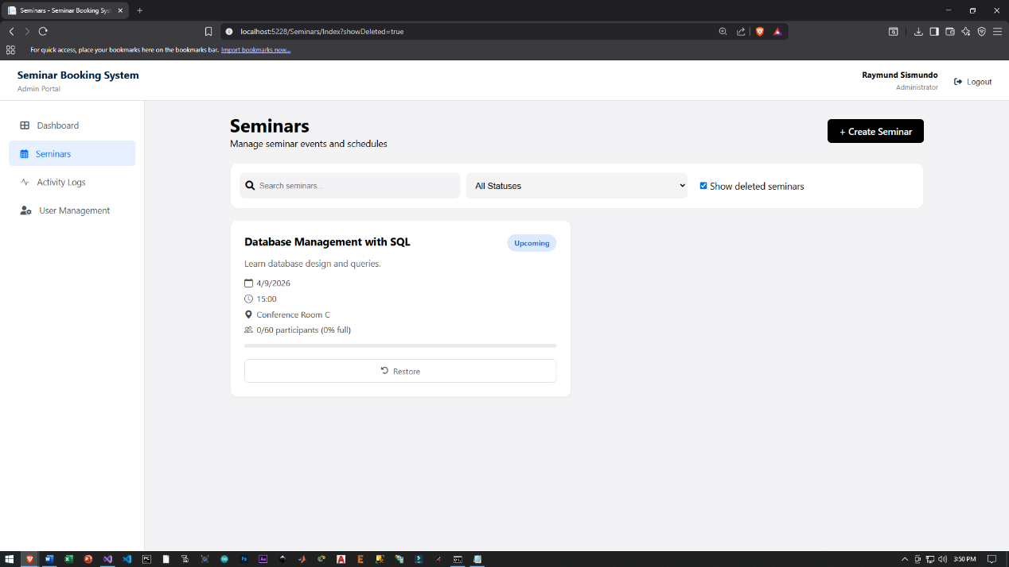
    - Restore Seminar

      - Deleted seminars can be restored back to the active list.
      - Ensures recovery of mistakenly deleted data.

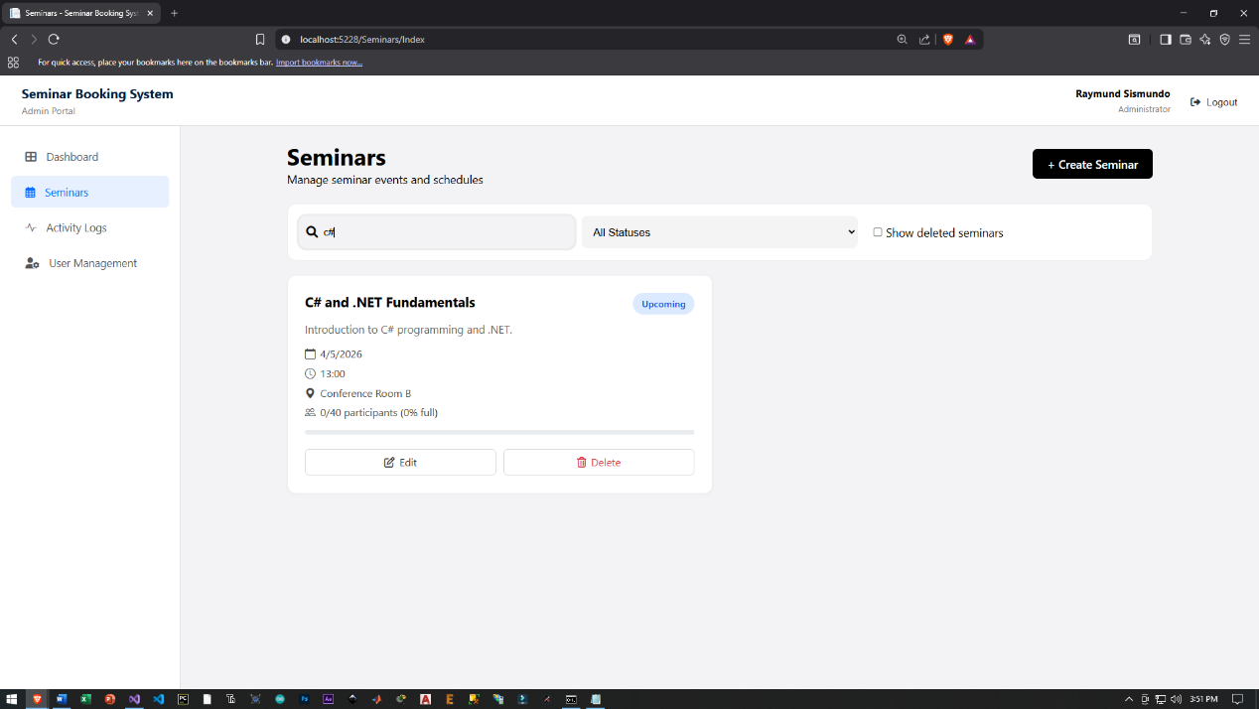
    - Search and Filter
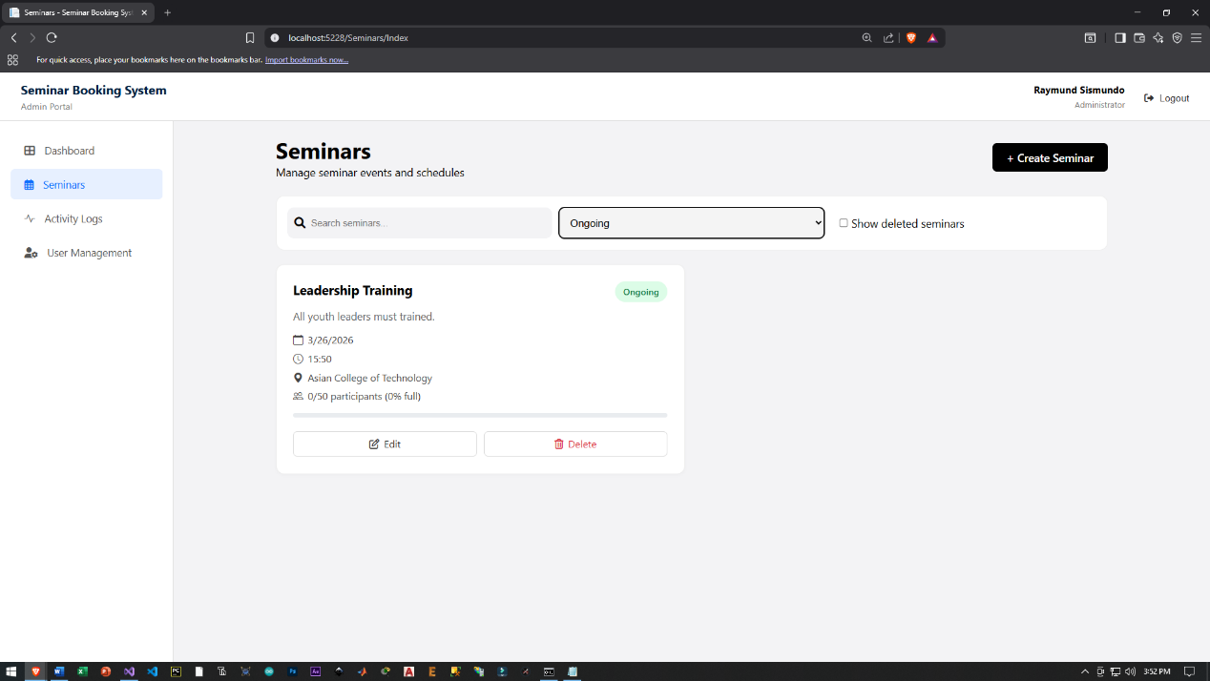
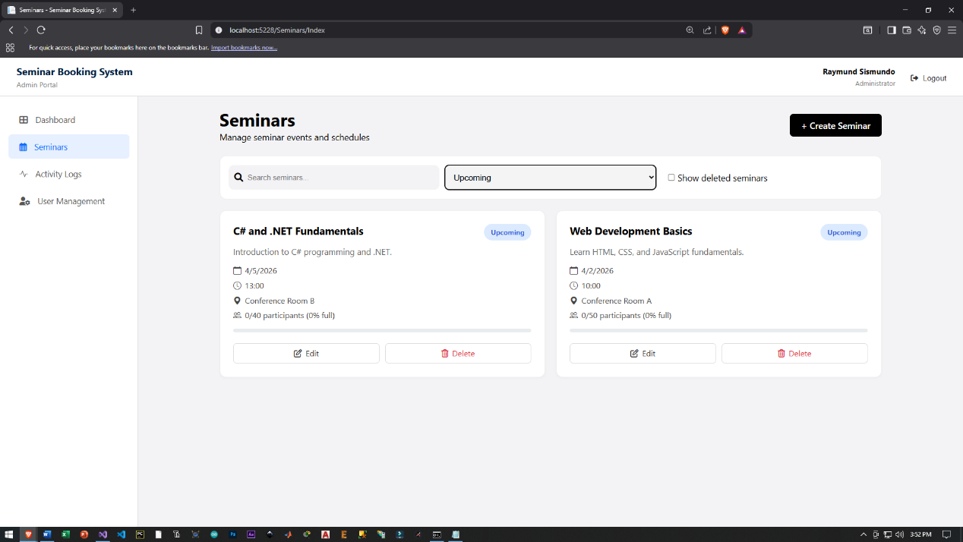

      - Allows admins to search seminars by title or keywords.
      - Helps quickly find specific seminars from the list.
    - Status Management
      - Each seminar has a status (e.g., upcoming, ongoing).
      - Status can be displayed dynamically based on date and time.
      - Helps admins track the current state of each seminar.

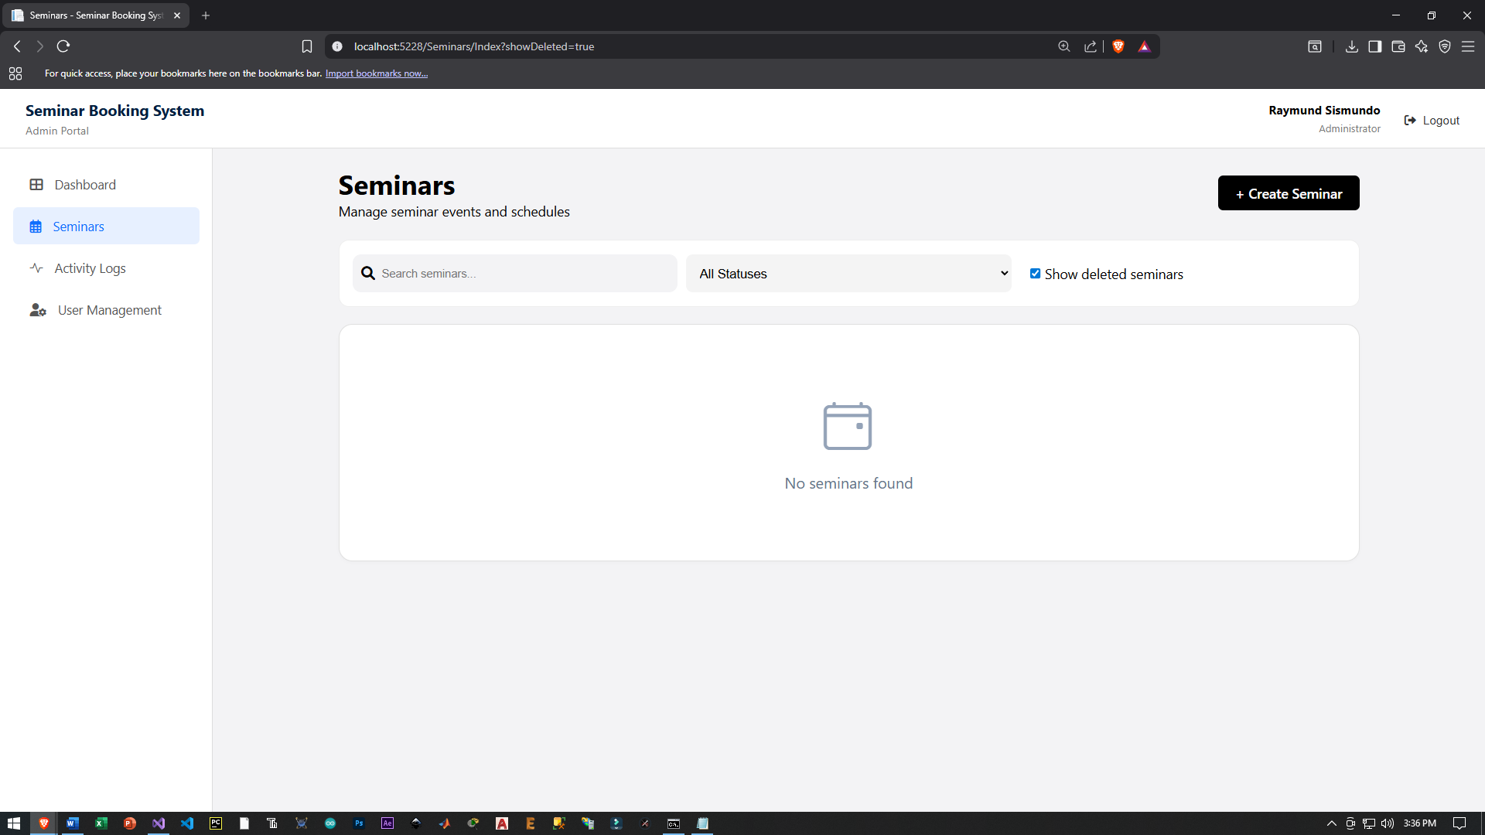

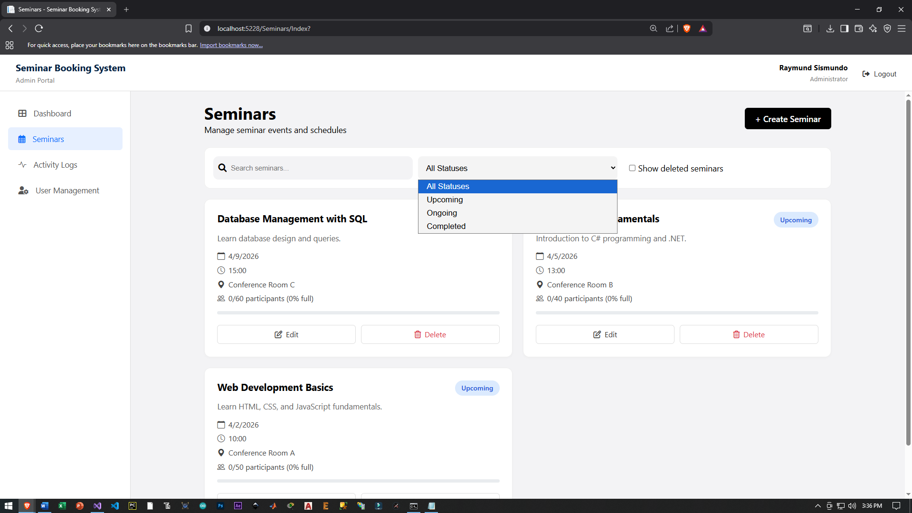

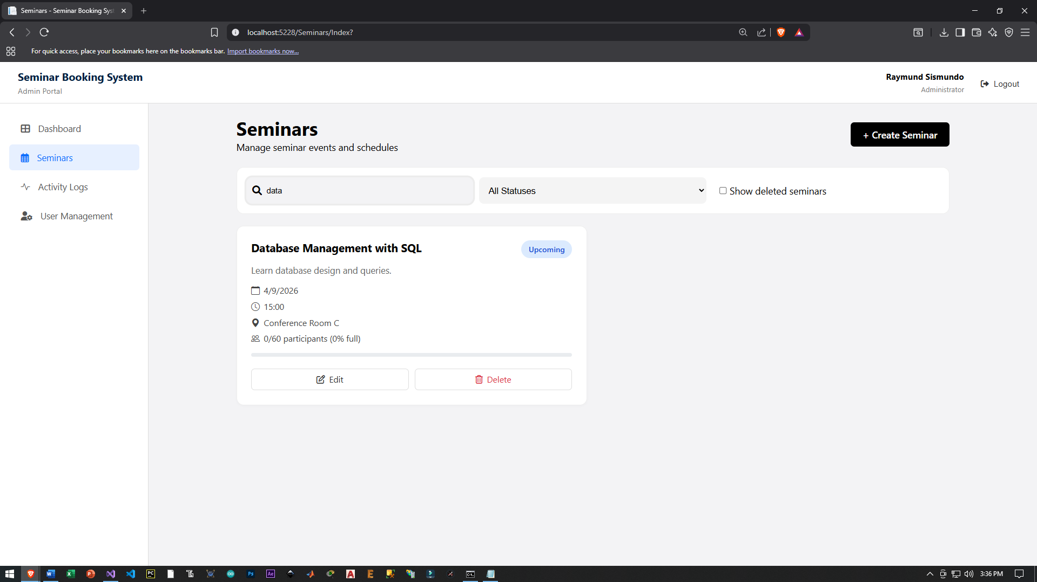

- Admin User Management Page

